Wireshark Lab: NAT v7.0  Supplement to Computer Networking: A Top-Down Approach, 7th ed., J.F. Kurose and K.W. Ross  “Tell me and I forget. Show me and I remember. Involve me and I understand.” Chinese proverb  © 2005-2016, J.F Kurose and K.W. Ross, All Rights Reserved | 

In this lab, we’ll investigate the Secure Sockets Layer (SSL) protocol, focusing on the SSL records sent over a TCP connection. We’ll do so by analyzing a trace of the SSL records sent between your host and an e-commerce server. We’ll investigate the various SSL record types as well as the fields in the SSL messages. You may want to review Section 8.6 in the text.

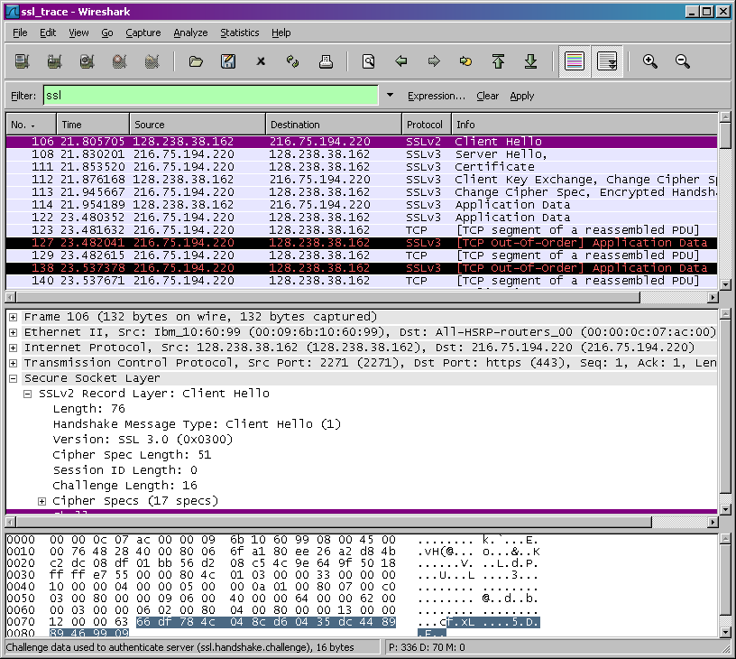

1. Capturing packets in an SSL session

The first step is to capture the packets in an SSL session. To do this, you should go to your favorite e-commerce site and begin the process of purchasing an item (but terminating before making the actual purpose!). After capturing the packets with Wireshark, you should set the filter so that it displays only the Ethernet frames that contain SSL records sent from and received by your host. (An SSL record is the same thing as an SSL message.) You should obtain something like screenshot on the previous page.

If you have difficulty creating a trace, you should download the zip file http://gaia.cs.umass.edu/wireshark-labs/wireshark-traces.zip and extract the ssl-ethereal-trace-1 packet trace.

2. A look at the captured trace

Your Wireshark GUI should be displaying only the Ethernet frames that have SSL records. It is important to keep in mind that an Ethernet frame may contain one or more SSL records. (This is very different from HTTP, for which each frame contains either one complete HTTP message or a portion of a HTTP message.) Also, an SSL record may not completely fit into an Ethernet frame, in which case multiple frames will be needed to carry the record.
Whenever possible, when answering a question below, you should hand in a printout of the packet(s) within the trace that you used to answer the question asked. Annotate the printout to explain your answer. To print a packet, use File->Print, choose Selected packet only, choose Packet summary line, and select the minimum amount of packet detail that you need to answer the question

- For each of the first 8 Ethernet frames, specify the source of the frame (client or server), determine the number of SSL records that are included in the frame, and list the SSL record types that are included in the frame. Draw a timing diagram between client and server, with one arrow for each SSL record.
- Each of the SSL records begins with the same three fields (with possibly different values). One of these fields is “content type” and has length of one byte. List all three fields and their lengths.

ClientHello Record:

- Expand the ClientHello record. (If your trace contains multiple ClientHello records, expand the frame that contains the first one.) What is the value of the content type?
- Does the ClientHello record contain a nonce (also known as a “challenge”)? If so, what is the value of the challenge in hexadecimal notation?
- Does the ClientHello record advertise the cyber suites it supports? If so, in the first listed suite, what are the public-key algorithm, the symmetric-key algorithm, and the hash algorithm?

ServerHello Record:

- Locate the ServerHello SSL record. Does this record specify a chosen cipher suite? What are the algorithms in the chosen cipher suite?
- Does this record include a nonce? If so, how long is it? What is the purpose of the client and server nonces in SSL?
- Does this record include a session ID? What is the purpose of the session ID?
- Does this record contain a certificate, or is the certificate included in a separate record. Does the certificate fit into a single Ethernet frame?

Client Key Exchange Record:

- Locate the client key exchange record. Does this record contain a pre-master secret? What is this secret used for? Is the secret encrypted? If so, how? How long is the encrypted secret?
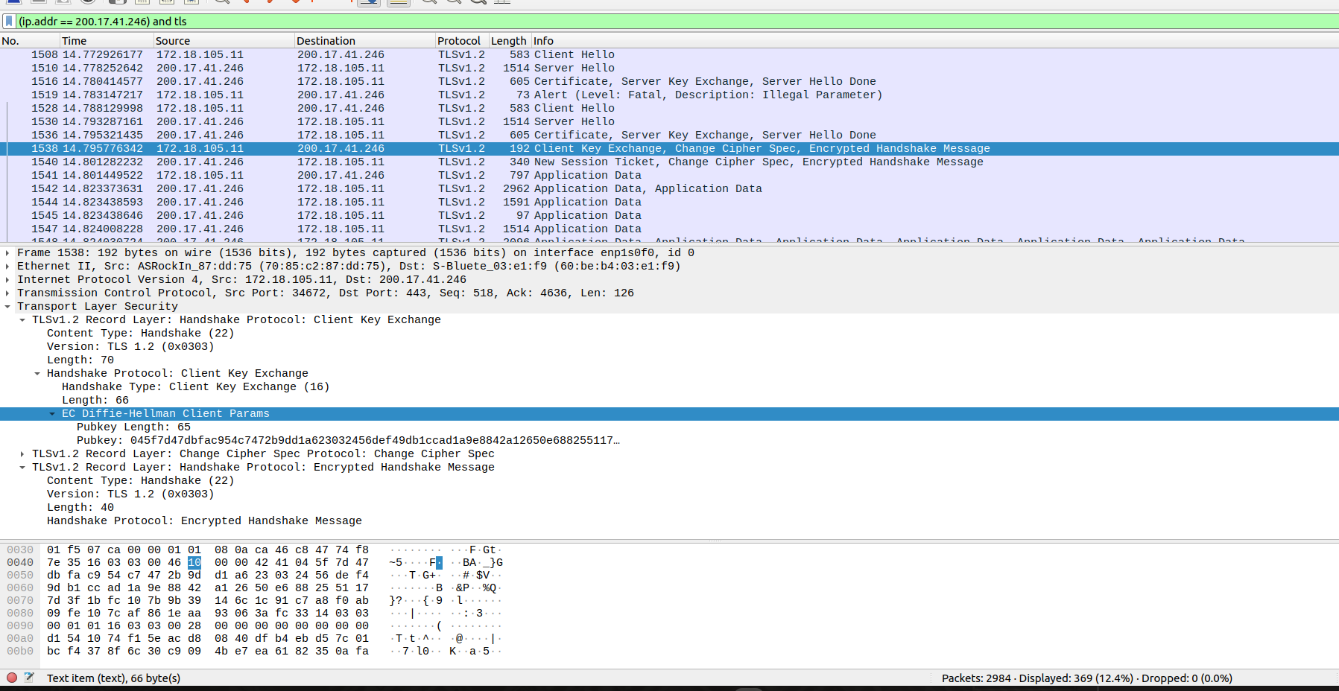
Não contém uma pré-master. Foi utilizado Diffie-Hellman que acontece uma troca de chaves publicas. Desta forma, não acontece uma troca de segredo é feito um calculo utilizando numeros privados atraves de uma geratriz de modulo. Tamanho é de 65.
Change Cipher Spec Record (sent by client) and Encrypted Handshake Record:

- What is the purpose of the Change Cipher Spec record? How many bytes is the record in your trace?

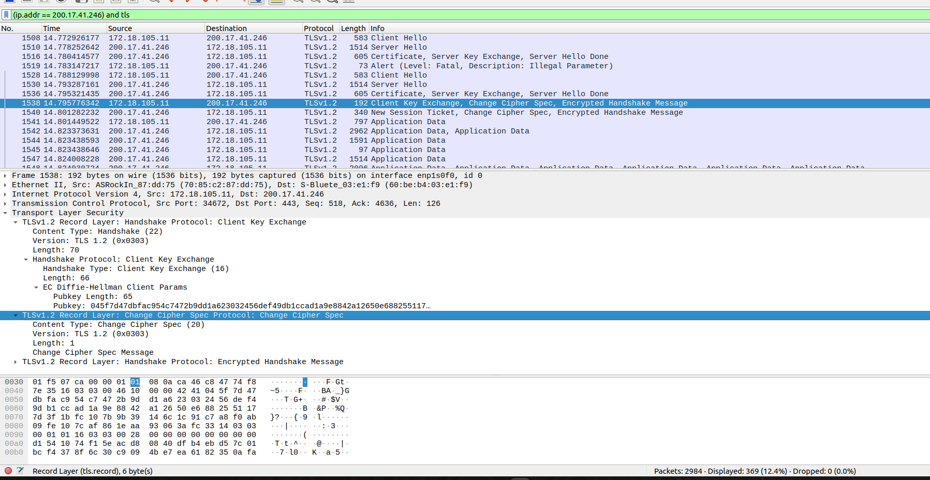
O CHANGE CIPHER SPEC PROTOCOL, que serve para sinalizar transições nas estratégias de cifragem. Consiste de uma única mensagem que é encriptada sob a especificação corrente de cifragem. Pode ser transmitida pelo cliente e pelo servidor para notificar à outra parte que o registro subseqüente será protegido por chaves de encriptação recém negociadas. O tamanho é de 1 byte.

- In the encrypted handshake record, what is being encrypted? How?
No registro de handshake criptografado no protocolo SSL/TLS, os dados sendo criptografados são as mensagens de handshake trocadas entre o cliente e o servidor durante a fase de negociação da conexão segura.Ou seja, durante o processo de estabelecimento da conexão, ocorre uma série de mensagens de handshake incluem informações como algoritmos de criptografia suportados, parâmetros de chave pública, acordos de chave e outras informações relevantes para estabelecer uma comunicação segura.
- Does the server also send a change cipher record and an encrypted handshake record to the client? How are those records different from those sent by the client?
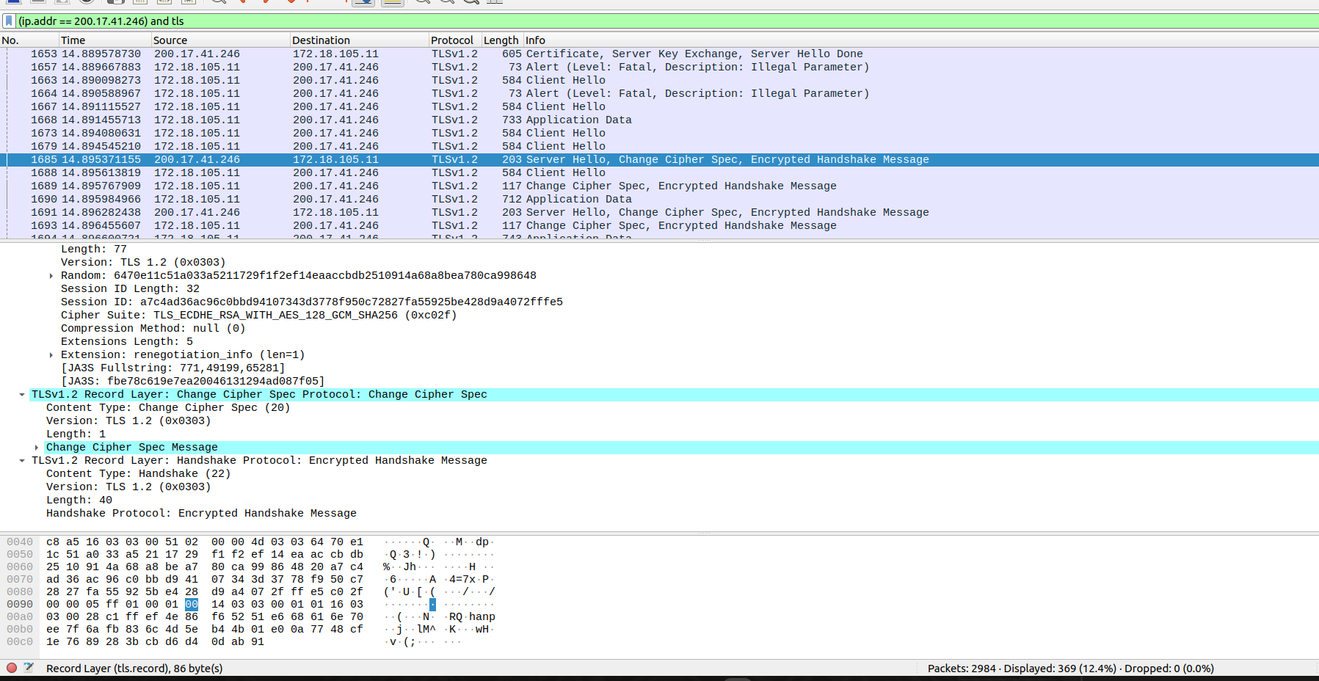
Os registros são os mesmo e são trocados para fazer a comunicação entre cliente e servidor após essa confirmação apresenta o mesmo tamanho de bytes tanto do cliente quanto do servidor.

Application Data

- How is the application data being encrypted? Do the records containing application data include a MAC? Does Wireshark distinguish between the encrypted application data and the MAC?
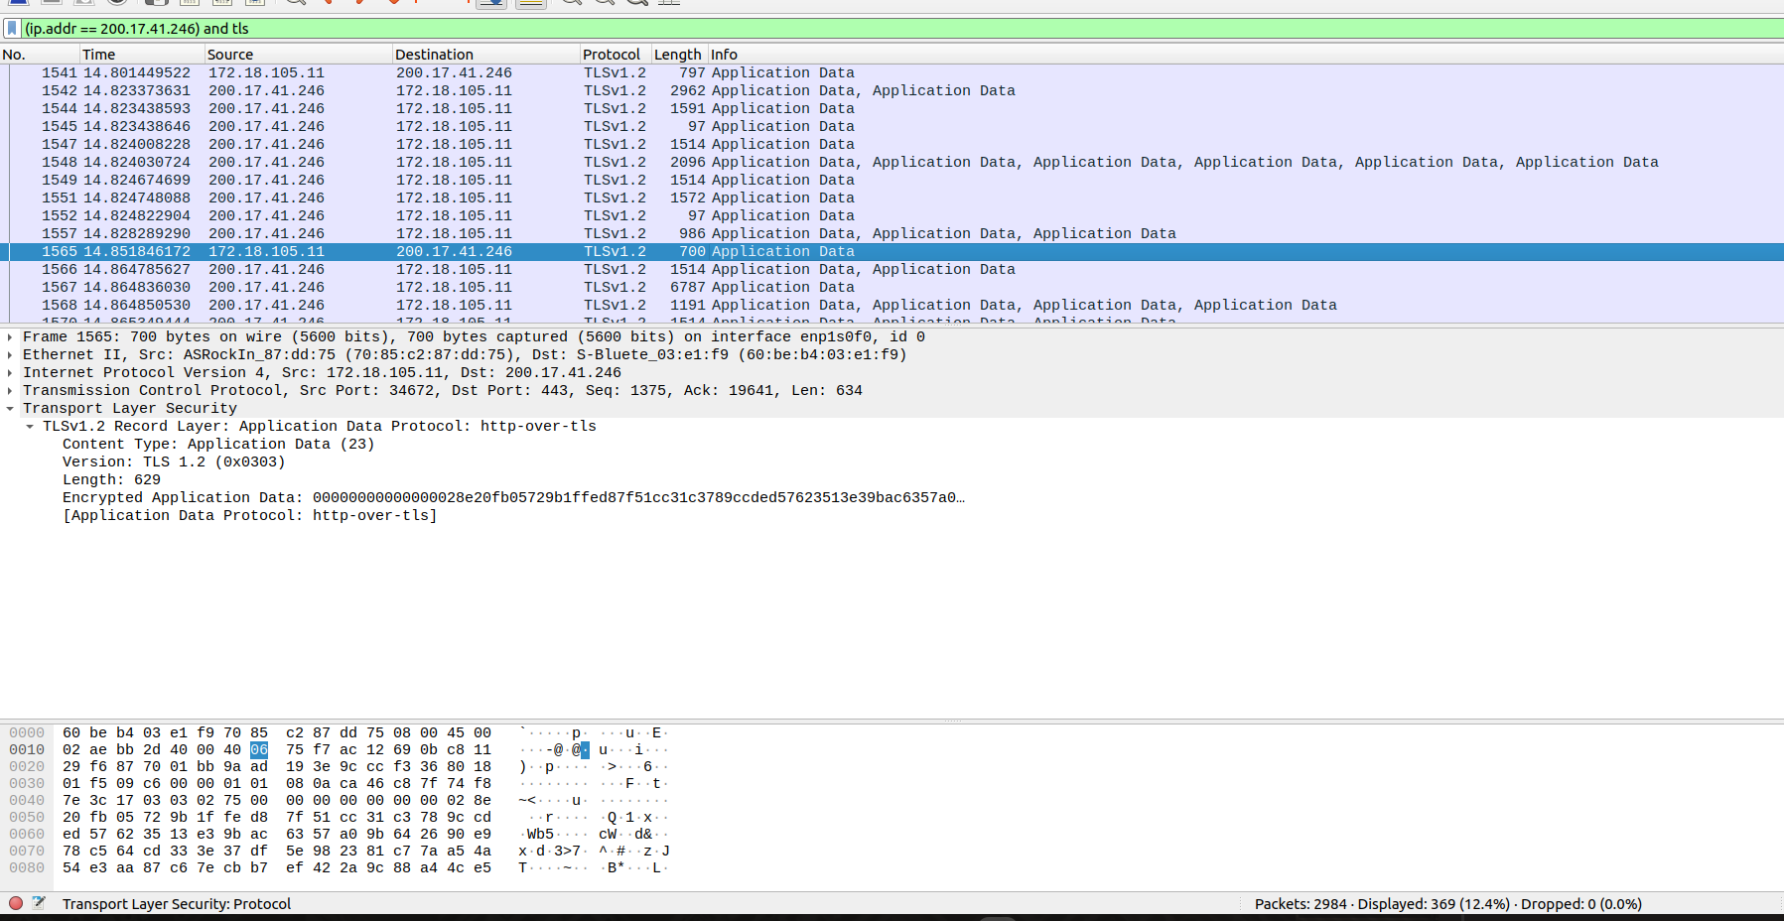
Não tem como visualizar nada devido ser criptografado e a unica maneira de ver seria atraves do lado do servidor.
- Comment on and explain anything else that you found interesting in the trace.
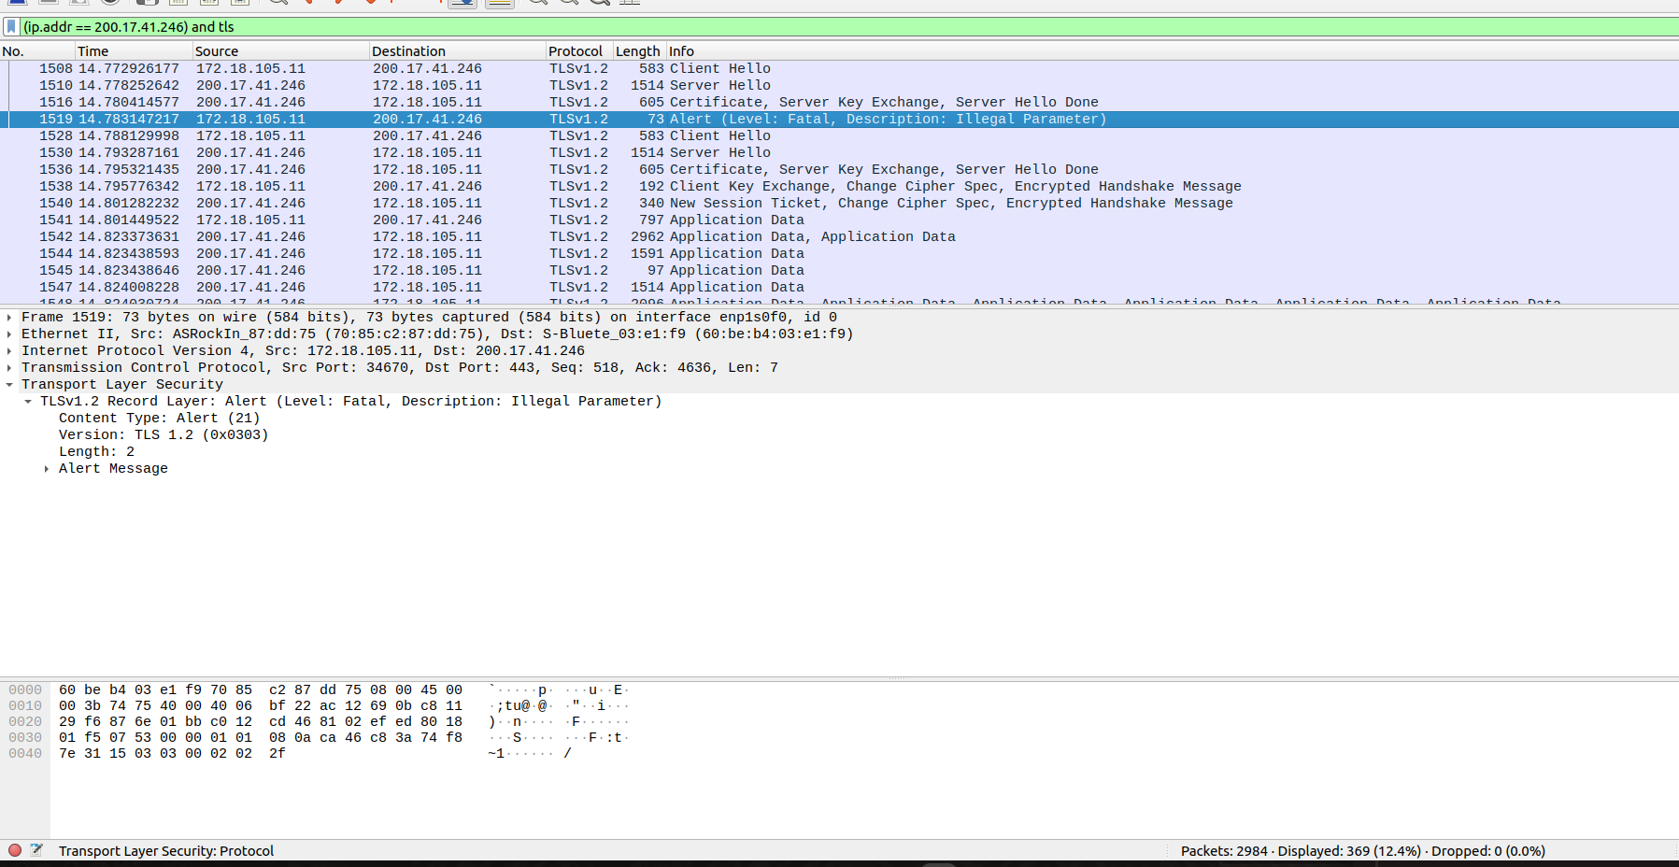
Um dos tipos de conteúdo suportados pela camada de registro TLS é o tipo de alerta. As mensagens de alerta transmitem a gravidade da mensagem
(aviso ou fatal) e uma descrição do alerta. As mensagens de alerta
com nível de fatal resultam no encerramento imediato da
conexão. Nesse caso, outras conexões correspondentes à
sessão podem continuar, mas o identificador de sessão DEVE ser invalidado,evitando que a sessão com falha seja usada para estabelecer novas
conexões. Como outras mensagens, as mensagens de alerta são criptografadas e compactadas, conforme especificado pelo estado atual da conexão. Desta forma, o valor 47 consiste em Um campo no handshake estava fora do intervalo ou inconsistente com outros campos. Essa mensagem é sempre fatal.

References to figures and sections are for the 7th edition of our text, Computer Networks, A Top-down Approach, 7th ed., J.F. Kurose and K.W. Ross, Addison-Wesley/Pearson, 2016.
What do we mean by “annotate”? If you hand in a paper copy, please highlight where in the printout you’ve found the answer and add some text (preferably with a colored pen) noting what you found in what you ‘ve highlight. If you hand in an electronic copy, it would be great if you could also highlight and annotate.

